*2024-2025*

**HAZELWILD FARM**

**SHOW SERIES**

5325 Harrison Road

Fredericksburg, VA

(540) 891-7101

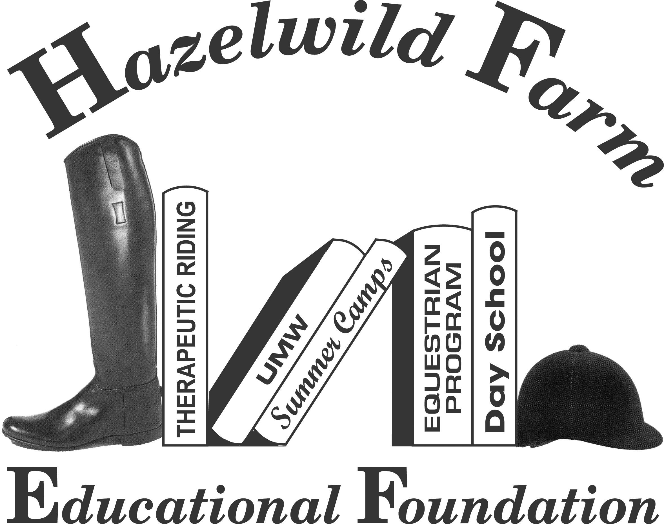

December 14, 2024 - Carla Francis

January 19, 2025 - Jeff Bradner

February 9, 2025 - Joan O’Keeffe

March 23, 2025 - Clyde Poarch

April 6, 2025 - Justine Betzler

May 18, 2025 - Gordon Reistrup

June 21, 2025 - Michelle Poarch

July 19, 2025 - Michelle Sturtz

August 24, 2025 - Alisa Berry

October 19, 2025 - Zach Parks

**Show Will Start at 8:00 AM**

VHSA Associate and BHSA Show

**All schooling breaks will be assigned. Some will be assigned either by division or name. Please check the Hazelwild Facebook page for schooling times and courses. Pre-entries $18/class. Post entries $25/class. VHSA Medal $25**

**VHSA Associate Divisions and Classes:**

| Pleasure Pony | Children’s Hunter |
| --- | --- |
| Pleasure Horse | Children’s Equitation |
| Green Pony | Adult Hunter |
| Green Horse | Adult Equitation |
| Pony Equitation | Working Hunter |
| Pony Hunter | Thoroughbred Hunter |
| Equitation on the Flat | Childrens/Adult Medal |

**BHSA Divisions and Classes:**

| Leadline | Maiden Hunter |
| --- | --- |
| Pre-Short Stirrup Equitation | Low Hunter |
| Short Stirrup Equitation  Long Stirrup Equitation | Limit Rider Hunter |
| Student Equitation | Green Hunter |
| Pleasure Pony | Thoroughbred Hunter |
| Pony Hunter | Working Hunter (2’9”, 3’) |
| Green Pony | Children’s Hunter |
| Pony Equitation | Children’s Equitation |
| Equitation on the Flat | Adult Hunter |
| Junior Pleasure Horse | Adult Equitation |
| Adult Pleasure Horse |  |

**Save the Date! The Aunt Sis Memorial Classic is September 6, 2025. Prize money will be given out to the Champion and Reserve Champion teams.**

*Shows will take place in our 185’ x 125’ indoor arena( December-March) or outdoor ring (April-October weather dependent) with state of the art footing. The footing is a sand, fiber, GGT blend that creates a very stable surface and also absorbs the energy impact of the hoof.*

In order to be eligible for a year end award you must attend a minimum of 5 Hazelwild Farm shows. This does not include the Aunt Sis. Classic

pre-entry forms are available at: **www.hazelwildfarm.com**

Completed pre-entry forms should be emailed to: **hazelwildfarm1897@gmail.com**

They are due 5 days before the show.

Show Manager – Teresa Seay

Show Secretary –TBD

Announcer – Donna Coley

**FOOD CONCESSIONS:**

CHEF HERB’S CATERING

1. **California Warm-Up**  (One trip per horse/rider combination, run all day)
2. **Leadline** – 50% Rider, 50% Suitability of Mount
3. **Pre-Short Stirrup Eq.** – Walk
4. **Pre-Short Stirrup Eq.** – Walk/Trot
5. **Pre-Short Stirrup Eq.** – Obstacle Course
6. **Short Stirrup** **Eq**. – W/T
7. **Short Stirrup Eq.** – W/T/C
8. **Short Stirrup** **Eq.**– O/F 18”
9. **Long Stirrup Eq.** – W/T
10. **Long Stirrup Eq.** – W/T/C
11. **Long Stirrup Eq.** – O/F 18”
12. **Student Equitation** – W/T
13. **Student Equitation** – W/T/C
14. **Student Equitation** – O/F 2’0” (May Trot)
15. **Pleasure Pony** – W/T
16. **Pleasure Pony** – Go As You Please
17. **Pleasure Pony** – W/T/C
18. **\*Pony Hunter/Green Pony Hunter** – O/F Sm 2’, Med 2’3”, Lrg 2’6”
19. **\*Pony Hunter/Green Pony Hunter** – O/F Sm 2’, Med 2’3”, Lrg 2’6”
20. **\*Pony Hunter/Green Pony Hunter** – U/S
21. **BHSA/VHSA Pony Equitation** Sm 2 ’, Med 2’3” Lrg 2’6” or 2’9”

**22 A. *Equitation on the Flat 14 and under**

**22 B. * Equitation on the Flat 15-17**

**23 A. *Jr. Pleasure Horse** – W/T

**24 A. *Jr. Pleasure Horse** – Go As You Please

**25 A. *Jr. Pleasure Horse** – W/T/C

**22 C. * Equitation on the Flat** **Adult**

**23 B. *Adult Pleasure Horse** - W/T

**24 B . * Adult Pleasure Horse** - Go As You Please

**25 B. *Adult Pleasure Horse**- W/T/C

**26. Maiden Hunter** – U/S

**27.** **Maiden Hunter** – O/F 2’0” (May Trot)

**28.** **Maiden Hunter** – O/F 2’0” (May Trot)

**29. Limit Rider Hunter** – U/S

**30.** **Limit Rider Hunter** - O/F 2’0”, 2’3”

**31.** **Limit Rider Hunter**  - O/F 2’0”, 2’3”

**32.** **Low Hunter** – U/S

**33.** **Low Hunter** – O/F 2’0”, 2’3”

**34.** **Low Hunter** – O/F 2’0”, 2’3”

**35. Green Hunter** – O/F 2’6”

**36. Green Hunter** – O/F 2’6”

**37. Green Hunter** – U/S

**38. Thoroughbred Hunter** – O/F 2’6”

**39. Thoroughbred Hunter** – O/F 2’6”

**40. Thoroughbred Hunter** – U/S

**41. Working Hunter** – O/F 2’6”, 2’9”, 3’0”

**42. Working Hunter** – O/F 2’6”, 2’9”, 3’0”

**43. Working Hunter** – U/S

**44. *BHSA/VHSA Children’s/Adult Amateur Equitation** 2’6” or 3’0”

**45. *Children’s/Adult Amateur Hunter** – O/F 2’6”, 3’0”

**46. *Children’s/Adult Amateur Hunter** – O/F 2’6”, 3’0”

**47. *Children’s/Adult Amateur Hunter** – U/S

**48. *VHSA/EMO Children’s/Adult Medal Class -** O//F 3’

**Leadline** - Open to riders 7 years of age and under as of 12/1/24. Riders may not cross enter into any class where they would be asked to trot.

**Pre-Short Stirrup Equitation** – Open to riders 10 years and under as of 12/1/24. Riders may not cross enter into any classes where they would be asked to canter or jump.

**Short Stirrup** **Equitation** – Open to riders 12 years and under as of 12/1/24. Judged on equitation. Riders may not cross enter into classes where they would jump over 18”. May trot fences.

**Long Stirrup** - Open to riders 13 and older.  Riders may not cross enter into classes where they would jump over 18”. May trot fences.

**Student Equitation** – Open to riders in their first or second year of showing over fences at 2’0” or higher as of 12/1/24. Riders competing in the Student Equitation Division are limited to two years only, whether they compete over fences or not. Judged on equitation. Courses may be trotted. Fences: 2’0”.

**Pleasure Pony** – Open to ponies ridden by Juniors. To be judged on manners, suitability, soundness, and way of going.

**Pony Hunter** – Open to ponies ridden by Juniors. *The division may be split to small/medium and large ponies if entries warrant. Fences: Small 2’0”, Medium 2’3”, Large 2’6”.

**Green Pony Hunter** – Open to ponies in their first or second year of showing at regulation heights as of 12/1/24 ridden by Juniors. Fences: Small 2’0”, Medium 2’3”, Large 2’6”. * May be split if entries warrant.

**VHSA/BHSA Pony Equitation** – Open to ponies ridden by Juniors. Fences: Small 2’0”, Medium 2’3”, Large 2’6” or 2’9”. The judge may select at least ¼ of the class to show at the walk/trot/canter and to perform additional tests at the judge’s discretion.

**Equitation on the Flat–**Open to juniors on horses or ponies, and adult amateurs on horses or ponies not entered in a pony division. To be shown at walk, trot, and canter both ways of the ring and judged on position, control, and guidance. Test 1-19 may be used, excluding those requiring work over fences.*May be split:Juniors(14&under), Juniors(15-17), and Adults, if entries warrant.

**Pleasure Horse** – Open to any horse. To be judged on manners, suitability, soundness, and way of going. * May be split: Junior and Adult, if entries warrant.

**Maiden Hunter** – Open to horses and ponies in their first year of showing over fences at 2’ or higher as of 12/1/24. No restrictions on riders. May trot fences.

**Limit Rider Hunter** – Open to horses and ponies ridden by Juniors and Adult Amateurs who are not entered in any classes jumping 2’6” or higher. An Adult Amateur can ride a pony if the pony is not competing in a pony class or division. These riders are not eligible for AA Equitation, Pony Equitation, or Jr./Children’s Equitation. Horses and ponies may cross enter into other divisions.

**Low Hunter** – Open to horses and ponies. No restrictions on riders. Fences: 2’0” or 2’3”.

**Green Hunter** – Open to horses in their first or second year of showing over fences at 2’6” or higher as of 12/1/24. Fences: 2’6”.

**Thoroughbred Hunter** – Open to Thoroughbreds registered with the Jockey Club or eligible to be registered. Fences: 2’6”.

**Working Hunter** – Open to all horses and ponies not entered in a pony division. May be split if entries warrant. Fences: 2’6’, 2’9” or 3’0” (Only 2’9” and 3’ are recognized by BHSA)

**VHSA/BHSA Children’s/Adult Amateur Equitation** – Open to horses ridden by Juniors and Adult Amateurs. Adults may ride ponies not entered in a pony division. Fences: 2’6” or 3’0”. The judge may select at least ¼ of the class to show at the walk/trot/canter and to perform additional tests at the judge’s discretion. * May be split if entries warrant.

**Children’s/Adult Amateur Hunter** – Open to horses ridden by Juniors and Adult Amateurs. Adults may ride ponies not entered in a pony division. Fences: 2’6” or 3’0”. * May be split if entries warrant.

**VHSA/EMO CHILDREN’S/ADULT MEDAL CLASS**: -Open to Junior/ Senior VHSA Members. Course must have no less than six jumps at 3', must include a combination, two changes of direction and at least two of the following: A roll back turn, a broken or bending line, an end jump, a narrow jump, or a long ride to a single jump. At least four exhibitors must be tested further over fences. **$25 for class**.

You may contact the show/barn office with questions regarding the horse show before the show.

**(540)-891-7101**

There are limited parking spaces on the grass in front of the indoor arena. There is plenty of gravel parking to the left when you pull in.

All Hunter classes will be judged on performance; including way of going, jumping style and soundness. Manners and suitability will be emphasized in Pony, Children’s and Adult Amateur Hunter classes.

All Equitation classes will be judged on hands, seat, guidance, and control.

You may join or renew your BHSA and/or your VHSA Memberships at the Secretary Stand. Please be prepared to pay with a check. Cash will not be accepted for membership fees.

**YEAR END AWARDS WILL BE GIVEN FOR CHAMPION THROUGH SIXTH PLACE.** Points will count from December 14, 2024 through October 19, 2025.

**SHOW RULES**

1. **ASTM/SEI certified helmets must be worn by ALL RIDERS when mounted**. Proper attire is required. Jackets may be excused by the judge.
2. Class Specification – Every class offered herein, which is covered by the rules and regulations of the current BHSA and VHSA rule book, will be conducted and judged accordingly. The judge’s decision is always final.
3. All exhibitors must be checked in at the in gate when their class is called.
4. Pre-entries are $18.00 per class. Post entries $25.00 per class. Non Showing fee of $25.00 for the day.$25 for the VHSA Medal Class
5. Entries will not be accepted without the release form signed.
6. All ages are as of December 1, 2024.
7. All horses/ponies on show grounds must present a negative coggins test taken within one year for each entry at each horse show. We will not keep coggins on file any longer. **Please email a copy with an entry form.**
8. **Entries must leave completed payment before leaving show grounds. $50.00 will be charged for returned checks. If you plan to pay in cash, please bring exact change. No change will be given.**
9. Points will be awarded using the VHSA/BHSA bonus point system.
10. Show management reserves the right to refuse entries, cancel and/or combine classes if necessary.
11. Exhibitors show at their own risk.
12. Lunging is permitted only in the ring near the entrance to the farm.
13. Schooling will be allowed in the ring at designated times. Show management reserves the right to split or to terminate schooling. Please see Facebook for the time table.
14. Food will be available on the grounds.
15. Hazelwild Farm Educational Foundation, any officials, and employees related to the foundation, and its board of directors, will not be held responsible for any accident or loss which may occur to any exhibitor, spectator, groom, property, or animal at the show.
16. Participants and spectators alike understand that horses are inherently unpredictable and dangerous and that equipment and ground conditions are equally unpredictable; and knowingly choose to participate and/or spectate, taking full responsibility for this choice. Entry onto the grounds constitutes knowledge and agreement with this policy.
17. In order to be eligible for a year end award you must attend a minimum of 5 Hazelwild farm shows. This does not include the Aunt Sis. Classic
18. See Horse Show Procedures

Horse Show Procedures

Pre entries are due five days prior to the show. Entries need to be emailed to [hazelwildfarm1897@gmail.com](mailto:hazelwildfarm1897@gmail.com)

Entry forms are available at: www.hazelwildfarm.com

Forms need to be completed with signatures and submitted via email only. Entries will not be considered until we have received ALL completed forms.

A complete entry includes: Entry Form, Coggins and Hazelwild Farm Waiver Release.

Day of entries need to be done at the secretary stand and will be $25 per class. VHSA Medal class is $25

Each individual must check out at the secretary stand before leaving the farm.

Checks should be made payable to Hazelwild Farm. If you plan to pay in cash, please bring exact change. No change will be given.

Based on pre entries, we will determine the number and times of schooling breaks. Schooling breaks will be for the people in that division only, unless you ask permission. This information will be on Facebook by noon the day before the show. Please use the outdoor ring to flat prior to your schooling break to promote efficiency.

No ribbons will be distributed at the ring. Please keep track of your awards. Ribbons will be next to the secretary stand. Please take them as you leave.

There is a hose available for rinsing horses and water located outside of the indoor near the bathrooms.

Chef Herb will be on the grounds for food.

Dogs must be kept under control and confined or leashed at all times.

Trainers and/or barns are subject to expulsion from the grounds if guidelines are not followed. Please discuss with each individual in your group the importance of following rules and the direction of horse show staff.

I**n order to be eligible for a year end award you must attend a minimum of 5 Hazelwild farm shows. This does not include the Aunt Sis. Classic**